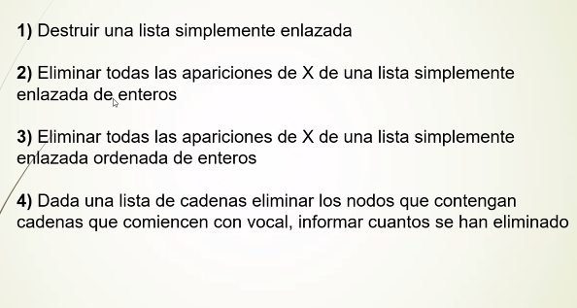
1 void destruye(Tlista *L){
Tlista act;
while (*L){
act = *L;
*L = (*L)->sig;
free(act)
}
}

